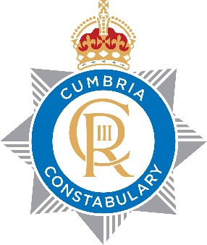
LIVE FACIAL RECOGNITION
REGISTER OF DEPLOYMENTS

Deployment Location | Date | Start & Finish Time | Watchlist Size | Total Alerts | True Alerts Confirmed | True Alerts  Un confirmed | False Alerts Confirmed | False Alerts Un confirmed | False Alert Rate | Outcome Arrest | Outcome Other | No Action | Faces Seen
Carlisle United | 7/3/26 | 14:42 – 17:35 | 78 | 3 | 3 | 0 | 0 | 0 | 0 | 0 | 3 | 0 | 6020

