Cumbria Constabulary
Diversity Report
2022 - 2023

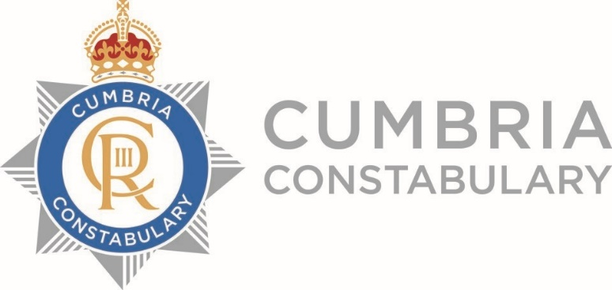

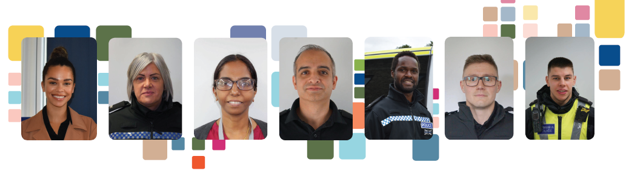

EQUALITY REPORT 2022 - 2023

CONTENTS
FOREWORD
BACKGROUND
OBJECTIVES
PUBLIC SECTOR EQUALITY DUTY
EQUALITY IMPACT ASSESSMENTS
OVERVIEW OF CUMBRIA CONSTABULARY
PROGRESS AGAINST EQUALITY ACTIVITY
APPENDIX

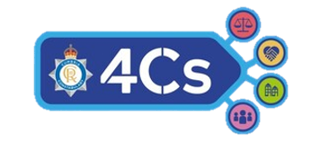
FOREWORD

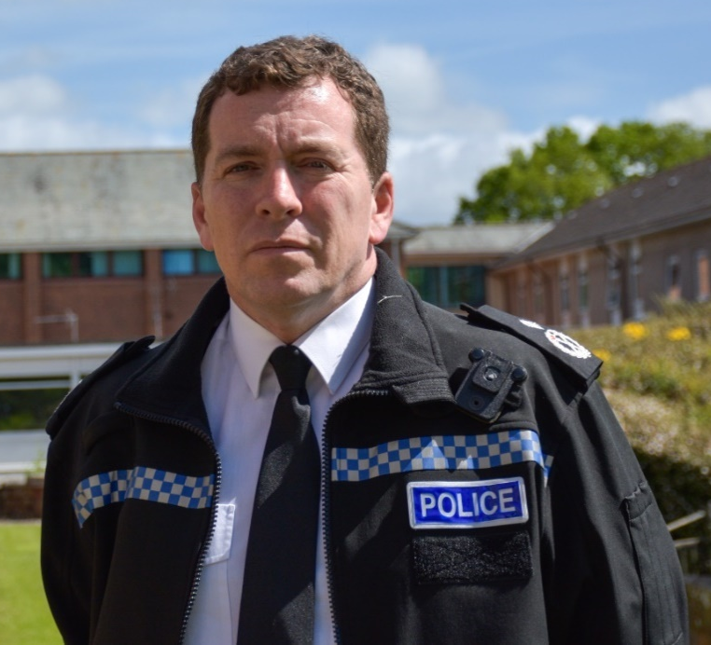
It is my privilege to publish Cumbria Constabulary’s latest Diversity, Equality, and Inclusion report.

Following my appointment in August 2023, I set the ‘4Cs’ priorities to drive our commitment to Deliver an Outstanding Police Service to Keep Cumbria Safe’.
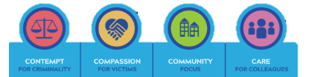

To ensure we deliver an exceptional service to all colleagues, residents and visitors, my inclusion objectives underpin the 4Cs’ priorities and strengthen all areas of our service delivery.

Cumbria remains one of the top performing constabularies in the country and I am proud to serve in this beautiful county alongside my colleagues. My officers and staff have shown me the extent of their dedication and hard work in the last 12 months, supporting the COVID response, recovery phases and implementing multiple changes, such as our new two area BCU structure. The diversity of our workforce has supported the effective delivery of these changes through resilience, cultural competency and innovation.

During 2023, we have worked at pace to positively advance a number of significant, inclusion and equality delivery plans. These plans focus on racial disproportionality, hate crime, violence against women and girls, Positive Action, scrutiny, reporting and engagement and internal culture.

However, we will never be complacent. Having listened to members of the public and our Staff Networks, I know that in many areas of policing, change has not occurred quick enough nor gone far enough. I am committed to achieving our ambitious objectives and continuously improving internal and external inclusivity, including increasing levels of transparency and scrutiny, to improve our policing service for all minoritised members of the public and staff, to help us to ‘Deliver an Outstanding Police Service to Keep Cumbria Safe’.

Rob Carden
Chief Constable.

Background

This annual diversity report accounts what action was undertaken in the period March 2022 to December 2023, to achieve our Equality and Diversity objectives, and deliver on the Constabulary’s priorities.

During 2023, Cumbria were part of the national Uplift Programme, and National Police Race Action Plan Icebreaker activity.
In November 2023 Cumbria had 1402 officers, serving a population of circa 500,000.

Supporting the effective delivery or our inclusion and diversity commitments are a number of strategies and plans including:
- Positive Action Strategy
- Cumbria Constabulary’s Police Race Action Plan Strategy
- Retention Strategy
- Diversity Strategy
- Violence Against Women and Girls Strategy
- Safer Neighbourhoods Strategy

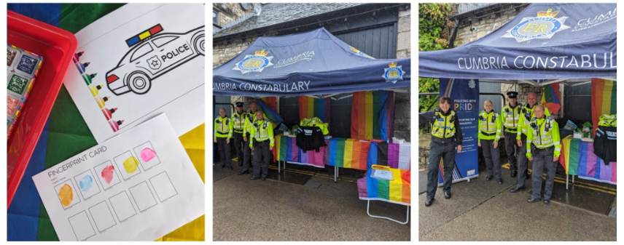

Our Equality Objectives

We have set four strategic objectives for the Constabulary, which align with the Chief Constable’s 4Cspriorities, to focus our equality, diversity and inclusion work in the coming years. They represent our long-term commitment and are as follows:

Chief Constable Rob Carden

Inclusive Service
Work together effectively with stakeholders, other police forces and key partner agencies to provide better services to local people.
A diverse workforce drives both resilience and exceptional performance. Supporting the developments of such a workforce is essential for us to deliver an outstanding service to keep Cumbria Safe.
Protect the most vulnerable
Scrutinise emerging crime types to understand trends, disproportionality and discrimination to ensure appropriate resourcing and support are in place.

Community Engagement
Increase trust and confidence in our service delivery for minoritised and vulnerable people by increasing engagement, consultation and independent scrutiny of any disproportionality, and removing bias from our policies and procedures.

Attract and retain a representative workforce
We will proactively develop and retain a workforce that is representative of the communities we serve.

The Public Sector Equality Duty

The Equality Act 2010 sets out the Equality Duty for all public bodies, to comply with a legal responsibility to tackle discrimination and promote equality on the grounds of age, disability, gender reassignment, pregnancy and maternity, marriage and civil partnership, race, religion or belief, sex and sexual orientation.
This involves:

Removing or minimising disadvantages experienced by people due to their protected characteristics.
Taking steps to meet the needs of people from protected groups where these are different from the needs of other people.

Encouraging people from protected groups to participate in public life or activities where participation is disproportionately low.

The Equality Act 2010 (Specific Duties and Public Authorities) Regulations 2017.
This Regulation requires public services such as policing, to publish information to demonstrate compliance with the duty, annually.

The information reported regards activity undertaken to understand, scrutinise and improve equality of services, policies and practices, impacting employees and people, who have protected characteristics.

We are also legally obligated to set and publish equality objectives, at least every four years.

We publish these within this report (see previous page), in our Diversity Strategy, on our website and on our internal systems.

For more information on our equality, diversity and inclusion strategy, please visit our website.

All police services are legally required to comply with the Equality Action 2010, and in particular Section 149, the Public Sector Equality Duty; and, Section 153, the Specific Duties.

The Public Sector Equality Duty requires that the police have due regard to the need to:
Eliminate discrimination.

Advance equality of opportunity

Foster good relations between people, those with protected characteristics and those without.

At Cumbria Constabulary we consider these requirements within every area of our work.

We are striving for fairness and equality of opportunity across every area of our service.

Equality Impact Assessment

The Constabulary is committed to advancing equality within our workforce and within the community we serve. As part of our legislative requirements to comply with the Equality Act 2010, we undertake Equality Impact Assessments on relevant Policies, Procedures, Strategies and activity.
Equality Impact Assessments provide us with the opportunity to scrutinise our activity, to ensure that our work does not create bias and impact adversely on anyone in the community and particularly with respect to race, religion, disability, gender, age and sexual orientation.
To enhance this process further, in 2024 all of our Staff Association are being trained to complete Equality Impact Assessments, to ensure the Constabulary consider lived experience for authenticity and resilience.
Our Strategic Advisory Group, made up of volunteer members of the public, are also consulted, where applicable on new policies, procedures, strategies, operations and activity, allowing us to receive firsthand feedback from members of the community, on how policing affects them or may affect them.
All members of staff undergo Equality Impact Assessment toolkits, training and support, appropriate to their involvement.

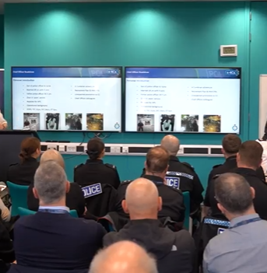

Overview of Cumbria Constabulary

Our police headquarters is based at Penrith, in Cumbria. We are a joint service, with the Police and Crime Commissioner also overseeing Cumbria Fire & Rescue Service.

The Chief Constable is supported by a chief officer leadership team of a deputy chief constable and two assistant chief constables.
In November 2023, Cumbria Constabulary comprised of police officers, police staff and PCSO's, supported by members of the special constabulary.


POLICE OFFICERS PCSO'S POLICE STAFF

SUPPORTED BY 47 SPECIAL CONSTABLES
And 77 POLICE VOLUNTEERS
1397
50
741

DIVERSITY HEADCOUNT SHOWN AS NUMBERS AND PERCENTAGES:

STAFF ROLE | HEADCOUNT |  | STAFF ROLE | FEMALE | MALE
Police officer | 1397 |  | Police officer | 43.2% | 55.8%
Police staff | 741 |  | Police staff | 66.8% | 33.2%
PCSO | 50 |  | PCSO | 64.0% | 36.0%
Special constable | 47 |  | Special constable | 40.4% | 59.6%
Total | 2235 |  | Percentages Total | 51.5% | 48.5%

STAFF ROLE | BME | DISABILITY | LGBT
Police officer | 3.7% | 7.9% | 6.7%
Police staff | 3.0% | 5.8% | 2.5%
PCSO | 2.0% | 13.0% | 13.8%
Special constable | 6.4% | 0.0% | 14.3%
Percentages Total | 3.4% | 4.6% | 3.8%

BLACK, MINORITISED ETHNIC WORKFORCE DIVERSITY REPRESENTATION AS PERCENTAGES:

STAFF ROLE | 2022 BME % | 2023 BME %
Police officer | 3.7% | 3.7%
Police staff | 2.5% | 3.0%
PCSO | 1.6% | 2.0%
Special constable | 0.0% | 6.4%
Percentages of grand total | 3.1% | 3.4%

Recruitment






In 2020, a national government target to increase 20,000 police officers across the UK accelerated opportunities to improve diversity in policing.

Cumbria Police increased officer numbers from 1199 (Nov 2019) to 1368 (Uplift end March 2023) through the Uplift Programme.

To ensure the constabulary utilised the opportunity, we enhanced our Positive Action Strategy in consultation with our Staff associations, to better support underrepresented groups and those with protected characteristics.

You can read more about Positive Action and our Positive Action Strategy here.

The completion of UPLIFT in March 2023, saw the Constabulary successfully increase our representation of BME officers by over 3%; proactively taking positive action to support our underrepresented colleagues to succeed and thrive, utilising Reasonable Adjustments to ensure all processes were equally achievable for all officers. Read more about our Fair Passport and Reasonable Adjustments here

This achievement saw the Constabulary build a workforce that is representative of our BME residential population.

Since the successful completion of Uplift, we have worked to retain our minortised colleagues, utilising Positive Action.

Since we implemented our Positive Action Strategy, incidents of attrition have only occurred due to changes to personal circumstances.

The door remains open to all our talented colleagues leaving, due to personal circumstance and we keep in touch to ensure they have information for support and any opportunities are identified which could result in their return to service.

Our recruitment, attraction, retention and progression plans are in place to support all under-represented members of the public, and those with protected characteristics, who may consider joining the police or wishing to develop and progress their policing career.

Our Black and Minority Ethnic representation in the police workforce has shown improvement in the police officer role and we are representative of the community that we serve.

However, we are not complacent and are working to achieve a workforce that is also representative of our transient population. This will see us working to increase our BME staff to 8% in the next 7 years.

We will continue to build on the success of Uplift, working with community group, key influencers, and specialist media, to ensure we reach all members of the public with our attraction messaging.

EQUALITY OBJECTIVES 2022 - 2024

Our Equality Action Plan is incorporated across several, significant delivery plans including, our Diversity strategy, Positive Action Delivery Plan, Violence Against Women and Girls, Hate Crime and Police Race Action Plan.

These delivery plans remain live, working documents, to allow us to continuously evolve activity, as work develops and as a result of ongoing stakeholder engagement.

Objective 1: Community Engagement

We will increase trust and confidence in our service delivery for minoritised and vulnerable people, by increasing engagement, targeted communication, consultation and independent scrutiny, of disproportionality to remove bias from our policies, procedures and activity.

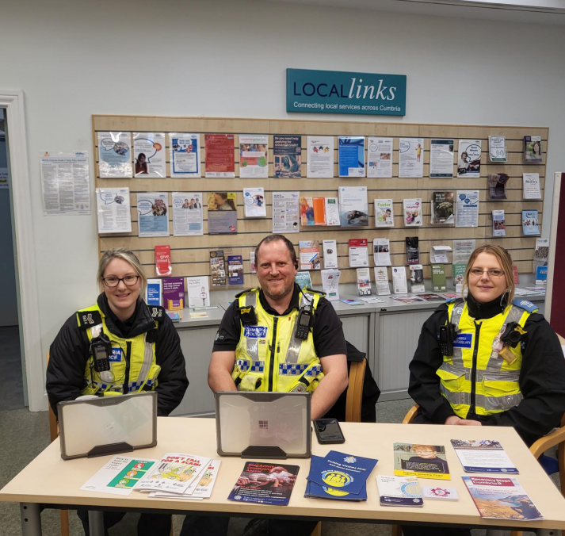
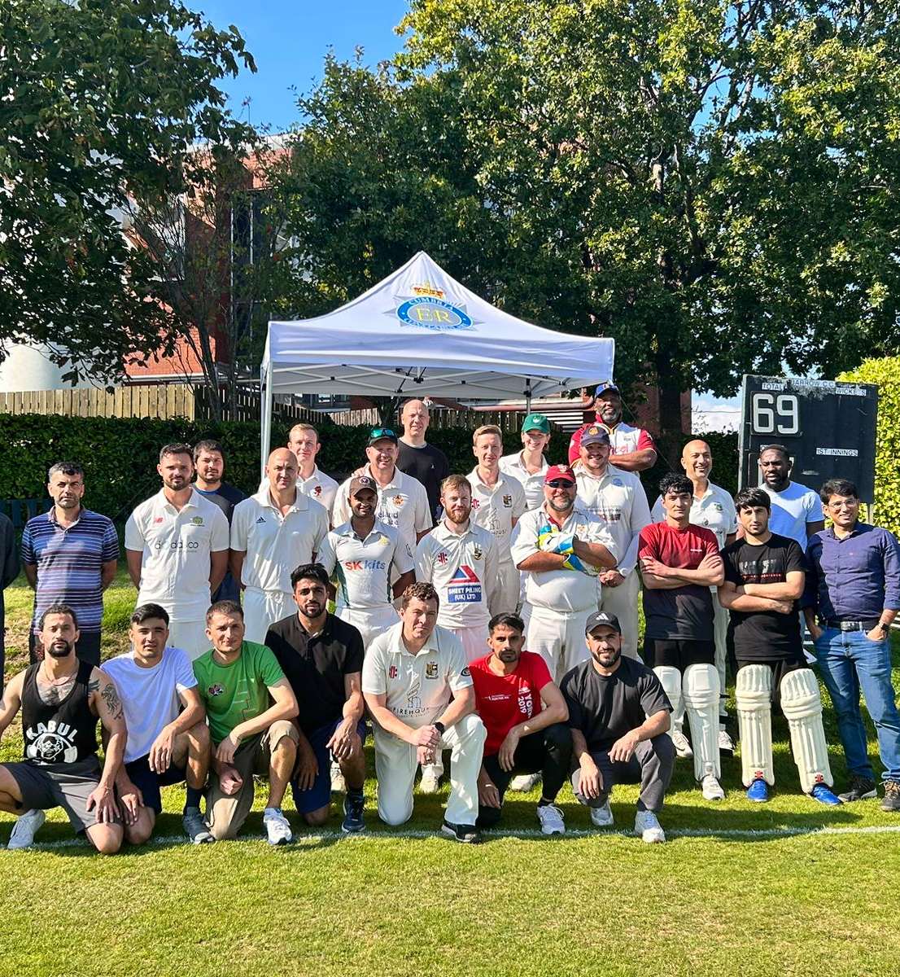
HIGHLIGHTS

In 2022 - 2023 Cumbria Constabulary
Implemented a localised Police Race Action Plan, working with members of the BME community and stakeholders to ensure meaningful change is achieved. This has already resulted in changes to various areas of training including Positive Action. It has also seen changes implemented to Body Warn Video to enhance transparency.

We have worked with a number of key community organisations representing minoritised people, faith-based leaders and groups and partner agencies to improve our scrutiny, oversight, insight, transparency and equality of service delivery.

We have embedded Positive Action and Positive Engagement across our Neighbourhood Policing Teams, in the Safer Neighbourhood Engagement Strategy.

We have held a number of community engagement events to improve the relationships between minoritised people and the police. These events have been met with positivity and will be built upon in 2024 through the Positive Action Strategy and Police Race action Plan strategy.



Objective 2: Attract and retain a representative workforce

We will proactively develop and retain a workforce that is representative of the communities
we serve.

Utilising Positive Action, our Positive Action Unit have developed an end-to-end support system, which has resulted in lower attrition rates for all officers, and only for minoritised officers leaving the constabulary in the last year.

You can find out more about out retention activity on our Positive Action Strategy and information page.

End-to-End Positive action support function

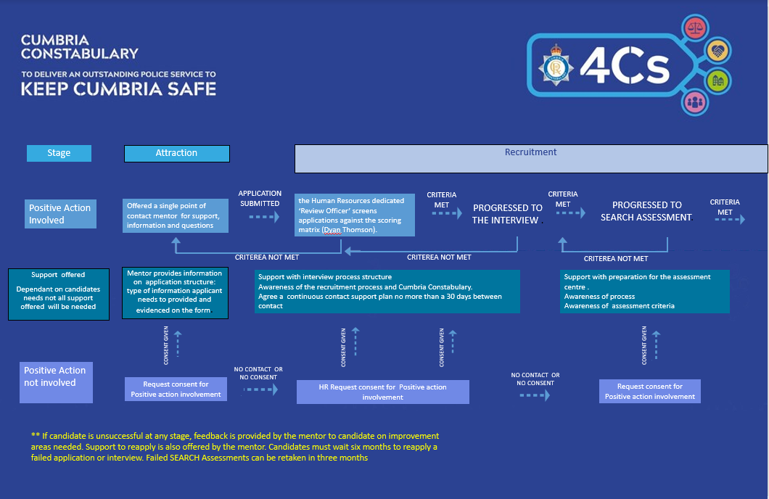

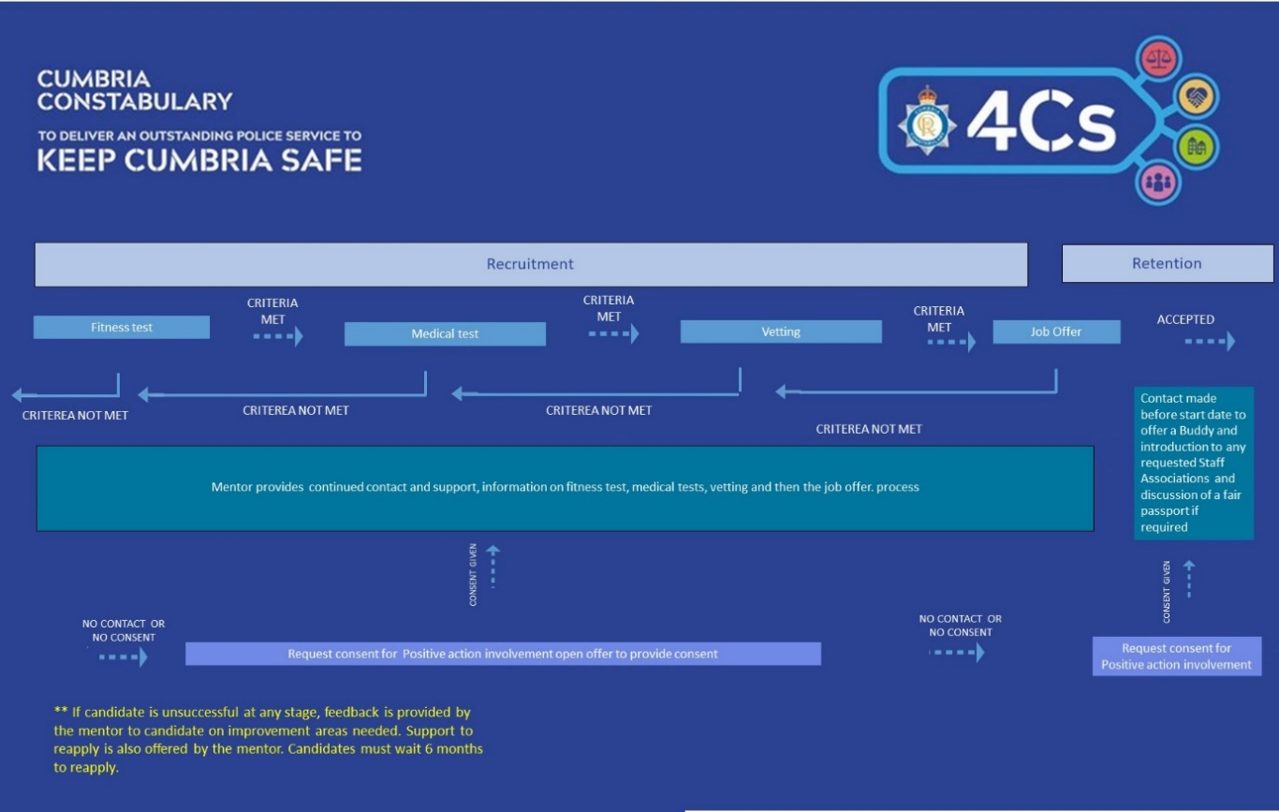

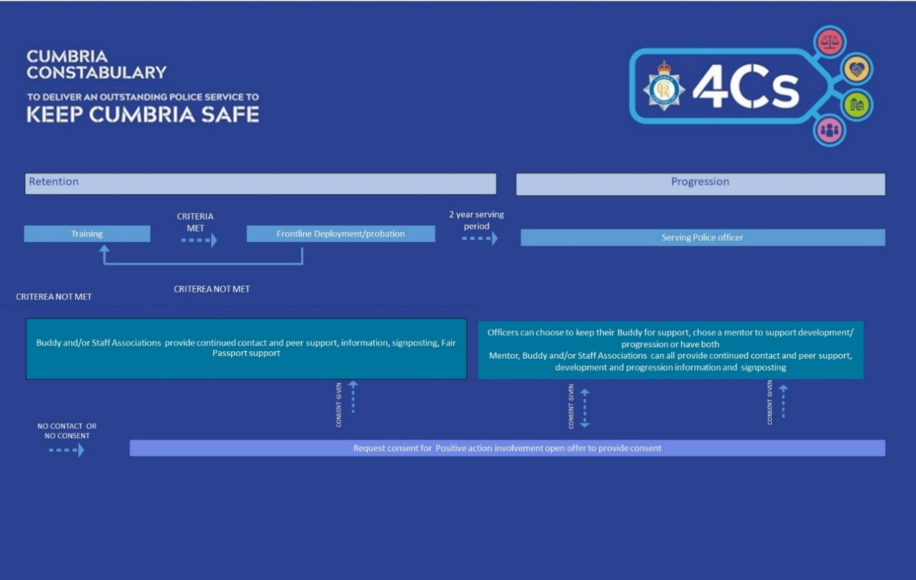

HIGHLIGHTS
Career progression support for officers and/or staff representing minoritised ethnicities or protected characteristics

Future Superintendent Programme
The aim of the programme is to provide a clear route for all officers to follow to progress their career towards becoming a superintendent.

Aspire and Inspire
These leadership programmes are delivered by the College of Policing. They support officers and staff to become better leader and to have confidence in their skills and abilities to lead effectively.

Learning and development
training activity for our leaders and new police officers in order to expand and uplift cultural
intelligence and awareness across the organisation.

Anti-racism training

As part of our commitment to supporting officers and staff and members of the public, the Constabulary offer SLT and new officers anti-racism training. The constabulary are committed to build upon this essential training. During 2024, we will develop and roll training out to all officers and staff.

Upstander Training

Delivered by the College of Policing this training supports officers and staff to become mentors and better line managers to minoritised officers and staff. The training also includes tools to embed anti-racist challenge into a work environment.

Promising practice Continuously scrutinising the strategic direction of equality across all plans and departments, undertaking benchmarking.

Support for gender related issues and representation to support the HeforShe campaign through the Women in Policing Network. This is supported by senior leaders in the organisation to progress key areas of gender inequality.
Our menopause network are supporting the stores department with a uniform working group. The menopause group are also working to raise understanding of menopause across the constabulary. They are supported by the diversity unit in areas of reasonable adjustments and signposting.
Fair Passports
We have trailblazed and innovated a fair passport where we record reasonable adjustments for officers and staff whether they have a disability or protected characteristic which negatively impacts on how they work in an unadjusted environment.

The passport records an individual’s reasonable adjustments, tailored to their personal requirements and job specification, to facilitate a supportive and productive working environment/station. This is a living document which changes according to circumstances.

Recruitment
Community focused
recruitment approach with proactive engagement from our communities

Regular recruitment events took place through 2022 to support our community members interested in finding out more about joining the police service.

You can find out more about the recruitment activity we undertook in the Positive Action strategy and Safer Neighbourhoods Strategy.

Objective 3: Protect the most vulnerable

Scrutinise emerging crime types to understand trends, disproportionality and discrimination to ensure appropriate resourcing and support are in place.

Hate Crime

Hate crimes and incidents continue to be closely monitored. During 2022/23, the number of crimes with a hate marker was 901. The Constabulary and partners take all reports of Hate Crime with sensitivity and respect. All crimes are duly investigated to hold offenders to account.

Within Hate Crime recording, multiple crimes can be recorded within a single incident and/or multiple crimes can be recorded during multiple incidents against the same victim.

Cumbria Constabulary work in collaboration with the Community Safety Partnership, with our partner agencies and with communities to educate people of hate crimes and their severity and to continue to encourage reporting.

Hate crimes recorded in 2022/23 Reported by the Home Office.
Race | Religion | Sexual orientation | Disability | Transgender | Total
531 | 37 | 174 | 150 | 37 | 901

Cumbria often experiences fewer incidents of hate crime compared to other forces both nationally and in the North West. Cumbria Constabulary had the 6th lowest level of reported Hate Crime in 2022/2023 when compared to the 43 other police constabularies.

However, the latest figures for crimes with a hate indicator show an annual increase of 15 crimes, which represents an increase of 1.7%.

Racial incidents remain the highest reported hate crime within Cumbria. In 2024 we will be publishing our Police Race Action Plan following the completion of the engagement stage. Areas of the Plan address improving Hate Crime Outcomes for victims and reducing offending.

Neighbourhood policing teams continue to play a vital role in dealing with hate crime, supporting victims and engaging with communities.

Regular inputs with schools continue, as well as work by the football unit to disrupt hate crime at football matches/events.

Disability and Transgender hate crimes are believed to be under-reported. Our front-line officers and public protection unit continue to work closely with these communities to increase confidence and reporting.

Targeted media campaigns, signposting how to report Hate Crimes and support services available, run regularly on the Constabulary’s social media accounts, with stakeholders encouraged to amplify messaging to their networks.

National Hate Crime Awareness week included a number of communications aimed to increase awareness of the impact of hate crime on victims. We have also been closely monitoring hate crime committed against staff and officers, to identify opportunities to further support staff.

We continue to work with high profile partner agencies such as Carlisle United to deliver Hate Crime Awareness media messages to a wider audience.

Improving public trust and confidence

Extensive work has gone into improving our call handling times.

The Constabulary is consistently achieving some of the highest levels of call handling performance nationally, further improving our services to our communities.

The Constabulary is consistently achieving the highest outcome rates nationally for offences relating to Violence Against Women and Girls (VAWG).

We have trained circa 100 Violence Against Women and Girls Champions in the Constabulary to support with raising awareness, providing scrutiny, supporting as resource at events, sharing ideas and amplifying communications.

The latest figures for public confidence in the local police service remained high at 76.1% for the whole experience.

Objective 4: Deliver a fair and inclusive, outstanding service.

Work together, effectively with stakeholders, other police forces and key partner agencies to provide better services to local people.

HIGHLIGHTS
For more information, please visit our website: www.cumbria.police.uk/diversity to find general information and contact details for the diversity unit.

You can also follow us on social media to get up to date information on our activity and signposting information.

We have partnered with anti-racist Cumbria since 2020 on a number of initiatives and activities.

Our Neighbourhood Policing Team’s Strategy and Plans are diverse to capture voices of minortised communities and members of the public. This includes regular engagements and opinion surveying of the local communities to identify concerns and issues.

We continue to have a good links with our Area Independent Advisory Groups, Strategic Independent Advisory Group, faith-based groups and Chaplains.

We work in partnership with Cumbria Refugee Action Group.

We work collaboratively with Community Safety Partnership and businesses leaders across Cumbria.

We work closely with the College of Policing and NPCC to ensure we are embedding best practice and are aligned to national plans.

We work collaboratively across all department within the Constabulary, to ensure all our plans are aligned and fair.

Equality Impact Assessments are conducted on relevant internal and external Policies, procedures and activity.

Partnership working

