Safeguarding Statement of Intent Cumbria Constabulary Cadets

Our statement

Note: The terms ‘child’ and ‘young person’ describe any person under the age of 18. References to ‘parents’ should be read as parents and carers inclusively.

Cumbria Constabulary acknowledges the duty of care to safeguard and promote the welfare of children and is committed to ensuring our safeguarding practice reflects statutory responsibilities, government guidance and complies with best practice and National Volunteer Police Cadet requirements. Everyone has a right to live free from exploitation, harm, fear and abuse and we are committed to safeguarding adults and children of all backgrounds and identities whilst under our care. We fully intend to train everyone within the required safeguarding practises with this being tracked within the Citizens in Policing Board.

We recognise that the welfare and interests of children are paramount in all circumstances. Regardless of age, ability or disability, gender reassignment, race, religion or belief, sex or sexual orientation, socio-economic background, all young people should have a positive and enjoyable experience whilst at Cumbria Constabulary Police Cadets in a safe and child centred environment and are protected from abuse whilst participating in activity we do.

We acknowledge that some children, are particularly vulnerable because of some aspect of their identity or circumstance and can be particularly vulnerable to abuse and we accept the responsibility to take reasonable and appropriate steps to ensure their welfare.
Whilst being a national movement, Cumbria Constabulary manage our own risk in relation to the safety of our cadets and leaders. The police officers, police staff and adult volunteers who support cadet units are expected to uphold the highest standards in child safeguarding, protection and supervision. As part of our commitment to this, all our adult volunteers (regardless of whether they are an employee of the Constabulary) are vetted by the Constabulary and in addition are required to have an enhanced DBS check which is renewed annually prior to being able to participate and support any cadet unit activity in any capacity.
To ensure overall scrutiny of the management of the Cadet programme the Citizens in Policing Board is in place with its own internal governance structure. The Cumbria Citizens in Policing Board reports into the Constabulary Operations and Scrutiny and Oversight Board which is the mechanism by which the Constabulary measures performance.
In collaboration with police forces in England and Wales, and with the involvement of national youth groups like the Scouts and Girl Guides, the National VPC team have created a national safeguarding framework that has been agreed by National Police Chiefs' Council and all Chief Constables have signed up to adopting. This offers all forces a streamlined and consistent approach to the reporting and managing of safeguarding concerns, the recruitment of leaders, training, organising activities and beyond. Cumbria Constabulary follow this framework and as a result, everyone involved in the VPC at every level knows what is expected of them at a local and national level and that confidential reporting and investigation is done in a consistent manner. Full structure of the Cumbria Constabulary VPC structure is detailed below;
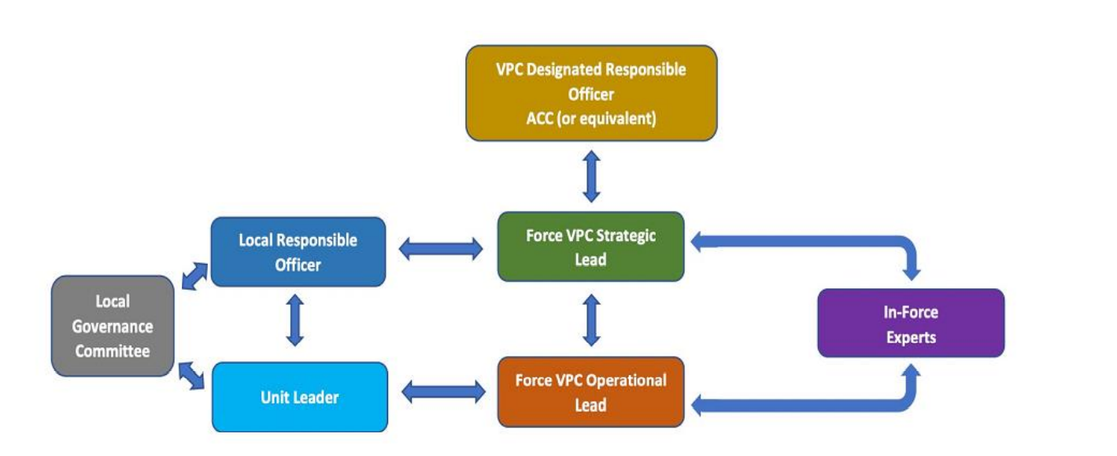
The National VPC team have a National Safeguarding Manager who is responsible for maintaining contact with police forces about this critical responsibility and about the standards and codes of conduct expected at a national level so that we can continue to work towards providing the safest and highest level of standards of youth safeguarding available across the Constabulary’s VPC units. This is all in addition to our internal VPC Safeguarding officer. The public expect and deserve to have trust and confidence in their police; even more so when it comes to protecting children and young people in our care when participating in activities organised by the police service.

Cumbria Constabulary’s VPC commitment to safeguarding

We will:
- Provide a safe and secure environment where young people can meet with others, learn about policing and policing issues and contribute to community initiatives – also ensuring having fun is at the heart of the experience.
- Promote and prioritise the safety and wellbeing of children and young people
- Recruit volunteers and staff safely, in line with the VPC Safer Recruitment Policy and Procedures
- Ensure that all staff and volunteers (legally responsible adults) working with children, young
people or adults at risk are carefully selected, are checked by the Disclosure and Barring Service (DBS) in addition to Police Vetting; have two appropriate references; and understand and accept their responsibility for the safety of children, young people and adults at risk in their care.
- Use our procedures to manage allegations against volunteers and staff and ensure all parents and cadets are aware of this procedure.
- Ensure all leaders and cadets volunteers follow our code of conduct, and if they do not, we will take action as set out by our policies and procedures.
- Ensure everyone understands their roles and responsibilities in respect of safeguarding and is provided with appropriate training to recognise, identify and respond to signs of abuse, neglect and other safeguarding concerns relating to children and young people.
- Provide effective management for all leaders through supervision, support, training and quality assurance measures so that all staff and volunteers know about our policies, procedures and behaviour codes and follow them confidently and competently.
- Record and store information securely, in line with data protection legislation and guidance.
- Ensure that confidential, detailed and accurate records of all safeguarding concerns are maintained and securely stored.
- Ensure health and safety measures are in place, in line with the law and statutory guidance, to provide a safe physical and digital environment.
- Ensure regular communication with the National Safeguarding Manager who is responsible for maintaining contact with police forces about this critical responsibility and about the standards and codes of conduct expected at a national level so that we can continue to work towards providing the safest and highest level of standards of youth safeguarding available nationally.
- Adhere to the National safeguarding framework that has been agreed by National Police Chiefs' Council and all Chief Constables.
Everyone involved in providing activities for children will be given access to appropriate learning opportunities to recognise, identify and respond to signs of abuse, neglect and other safeguarding concerns relating to children and young people.
If you or anyone you know has any concerns about the safety of anyone involved in the Cumbria Constabulary Volunteer Police Cadets please contact Cumbria Constabulary Citizens in Policing Team (CiP@cumbria.police.uk).
Alternatively, you can contact the below to report or discuss any safeguarding concern;
- Direct to Professional Standards Department – PSD-ACUIntel@cumbria.police.uk
- External VPC Safeguarding Manager – Helen Nellany vpcsafeguarding@vpc.police.uk
- NSPCC Helpline/Number 0800 800 5000 or email help@nspcc.org.uk
- The Independent Office for Police Conduct 0300 020 0096 or cadets@policeconduct.gov.uk
- Cumbria Constabulary Safeguarding Lead for VPC– Superintendent St. Quintin - Daniel.StQuintin@cumbria.police.uk

Other points of contact are:-
The NSPCC helpline 0800 800 5000 or email help@nspcc.org.uk
The Independent Office for Police Conduct 0300 020 0096 or cadets@policeconduct.gov.uk

VPC child protection referral process flow chart:
